Objectives:

* While loop
* Do while, and for loop
* Arrays and Random Generator

**There are 4 challenge exercises, each worth 25%**

 Java, *iteration* is a technique used to sequence through a block of code repeatedly until a specific condition either exists or no longer exists.

The **while** **loop** uses a **Boolean** expression of **true**, it will loop until it reaches a **false** condition

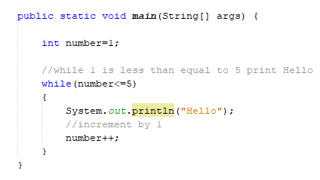

Incrementing by 2 >> change the number ++ to number+=2

To decrement Java uses –

Now, change the <= to >=, which changes the conditional statement to 1 is greater then or equal to 5, which is a false statement.

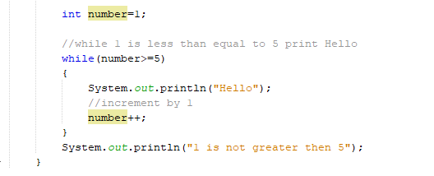

Creating an infinite loop by using the true Boolean expression. An infinite loop is a loop that does not stop

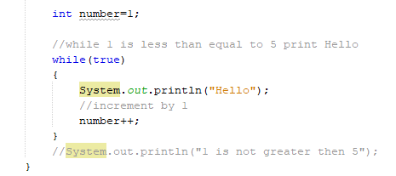

Comparing two variables, while 1 <= 5, which is a true statement, print the word Hello, 5x

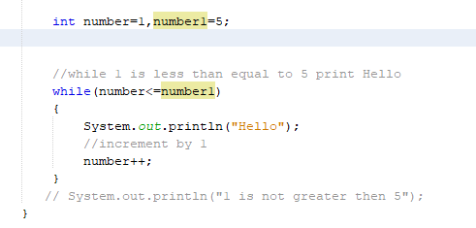

Output

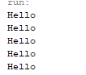

Using a Scanner for user input

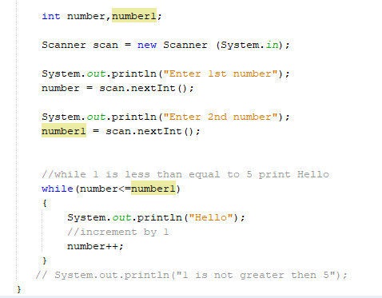

Creating the temp program using a while loop

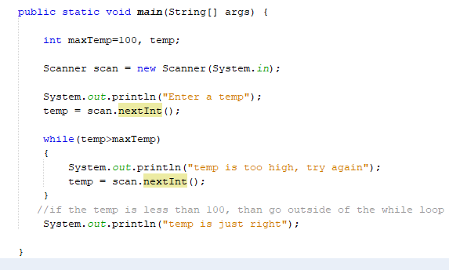

Using two while loops and two scanner classes

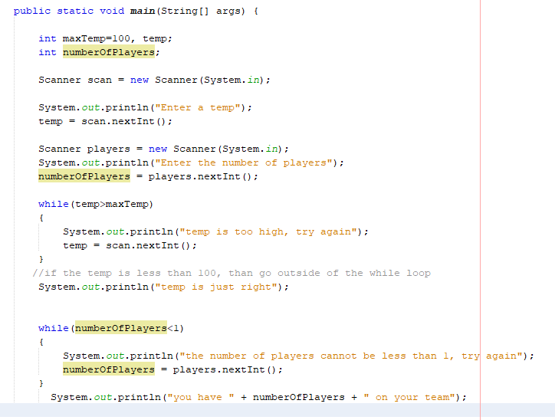

**Challenge Exercise #1:** Complete the following program below, the program will ask how many students in the class. Use a loop.

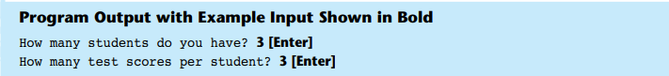

**#1 print screen the output with code below here.**

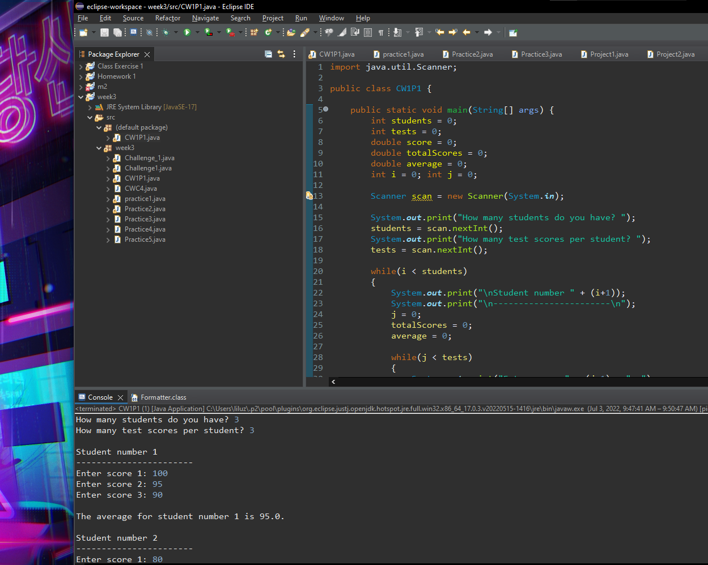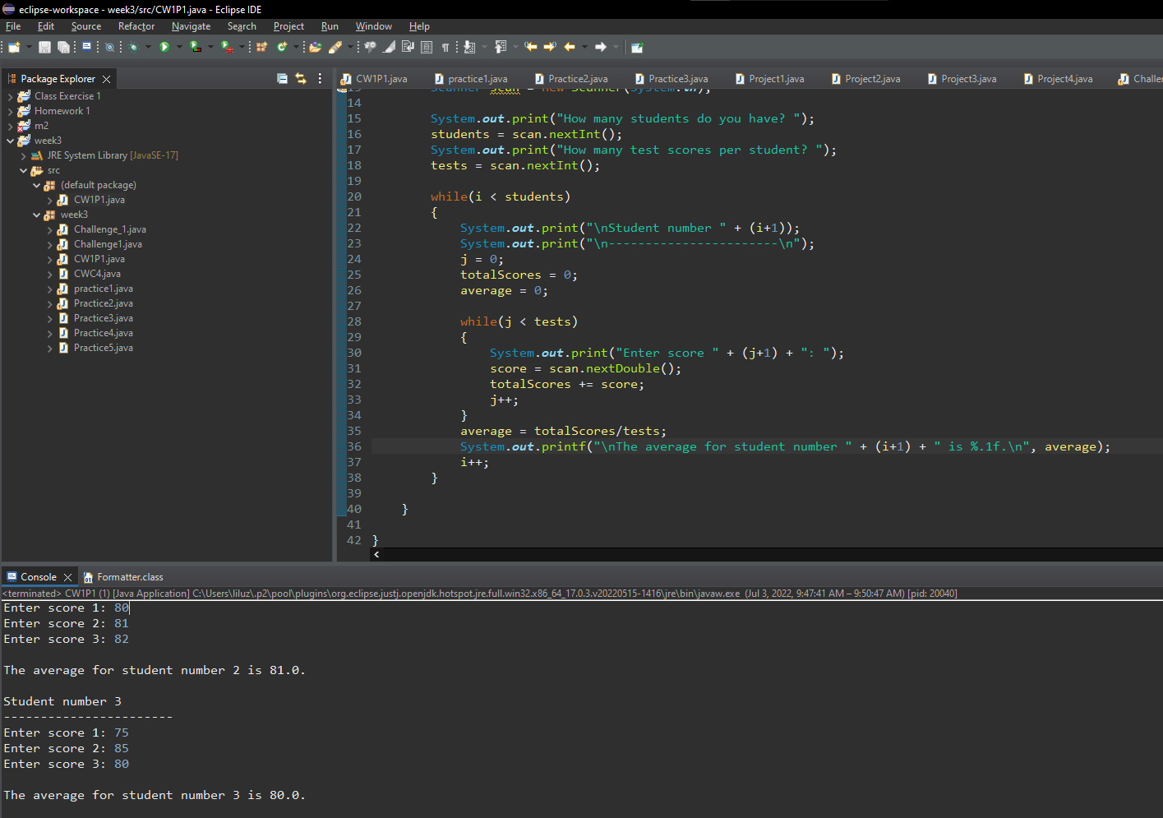

The **do** **while** loop is a little different than the while loop. The do while loop is a **post** **test** loop, meaning it does not test the Boolean expression until it has completed the iteration. The **do** statement completes at least 1 iteration, even if the Boolean expression is false. A while loop is a **pretest** loop

You should use the do while loop if you want to make sure the loop **executes** at **least** **once** & then check for the while condition.

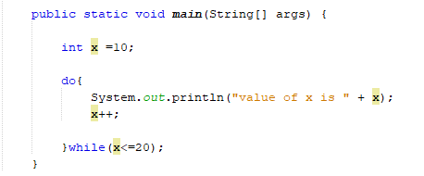

Execute the do 1x and then check for the while condition x=10 is less than or equal to 20. Now, change the **x=10 to x=21** and run the program

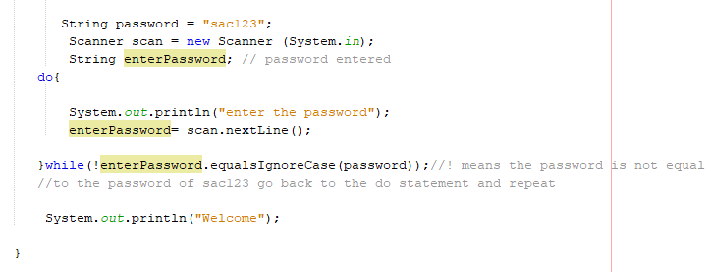

Another example… for test scores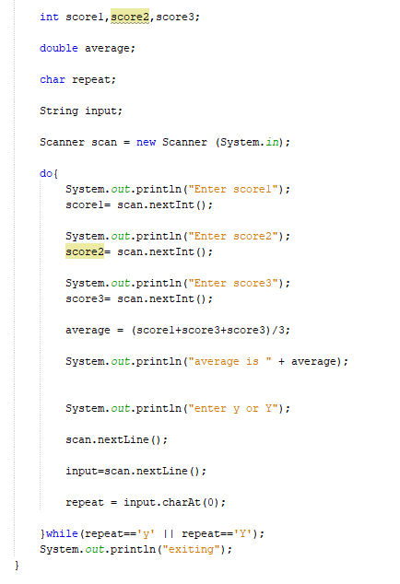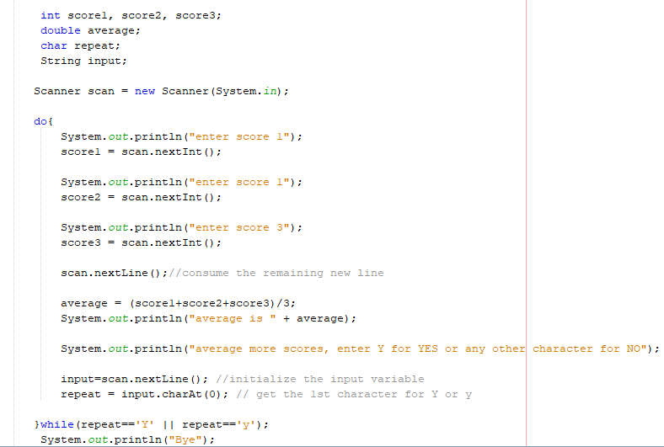

**Challenge Exercise #2:** Complete the following program below, the program will ask how many friends and write the friends name in a text file.

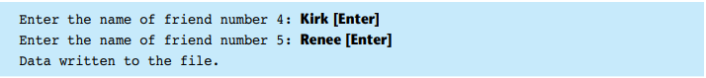

**#2 print screen the output with code below here.**

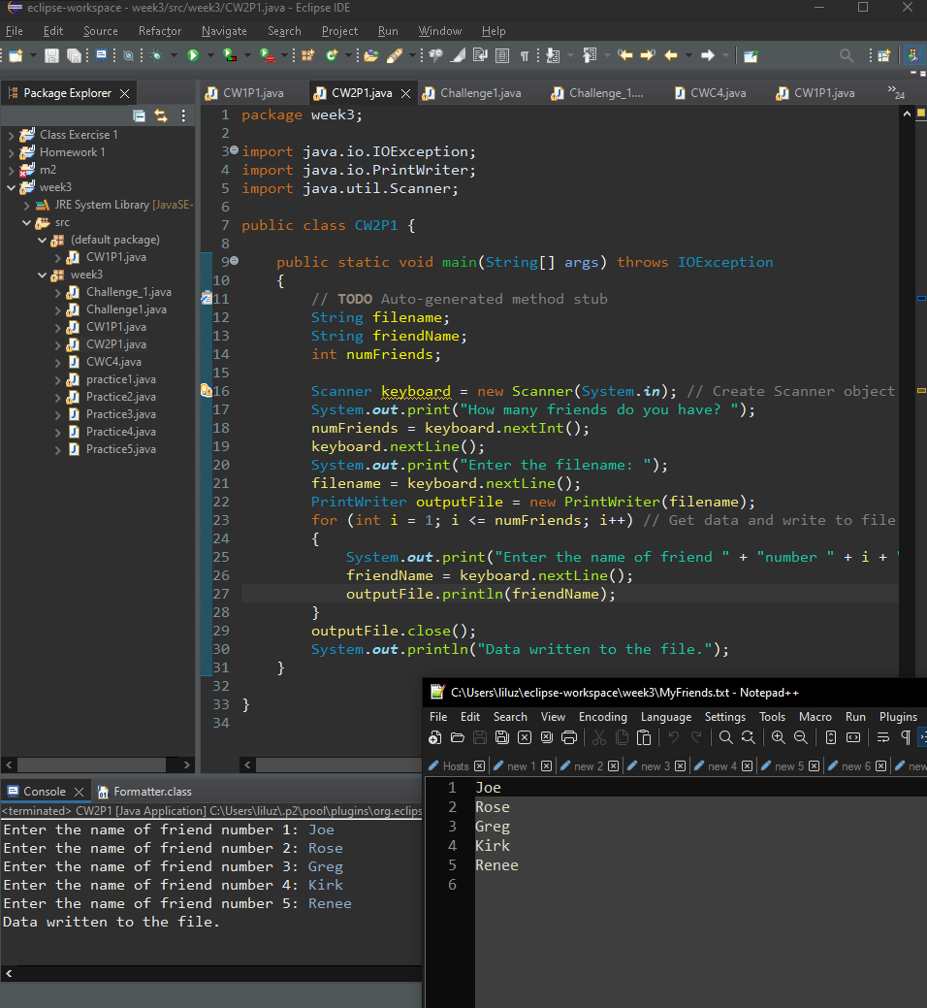

The differences between the for loop compared to the while and do while loops are that the for loop is known for performing a known number of iterations.

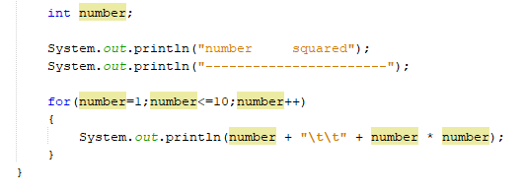

1. Numbers starts with, in our case it is 1
2. Conditional value >> number <=10
3. Increment >> by 1

Now, add a Scanner class to the program

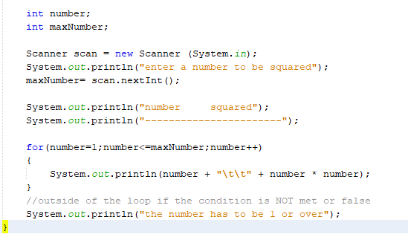

Example of another for loop

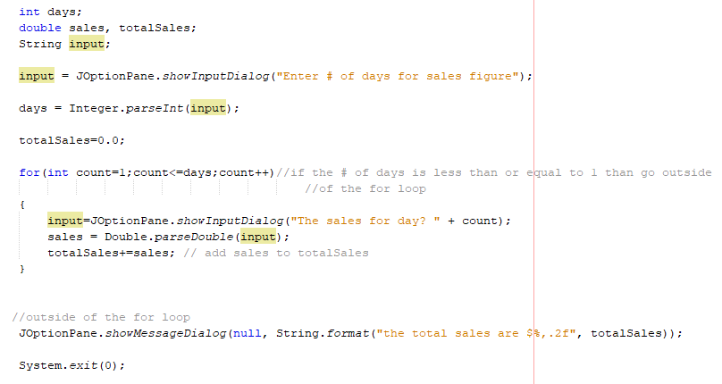

Example of a multiplication table using a for loop

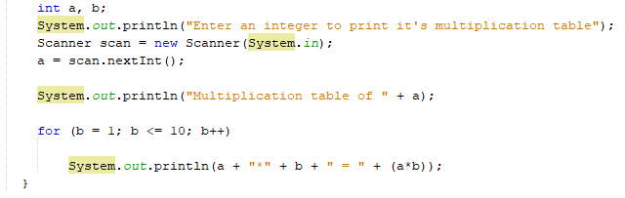

Nested Loops, a nested loop is a loop that runs in parallel one after another, just like a nested if statement.

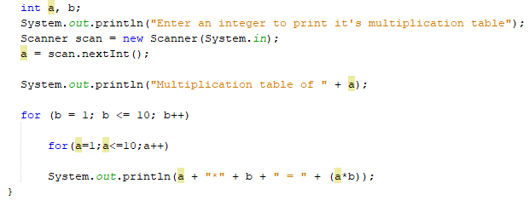

Example of a for loop for Test Average

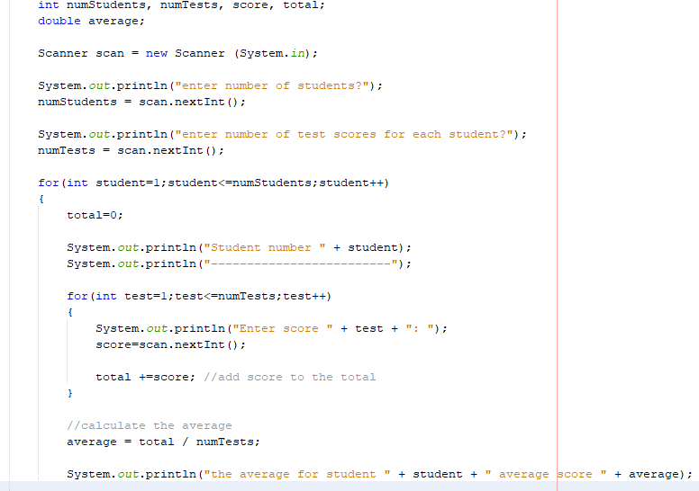

Here is an example of creating an array table. An array table is nothing but a table that lists array indexes and its assigned parameters.

**Challenge Exercise #3:** Complete the following program below.

**#3 print screen the output with code below here.**

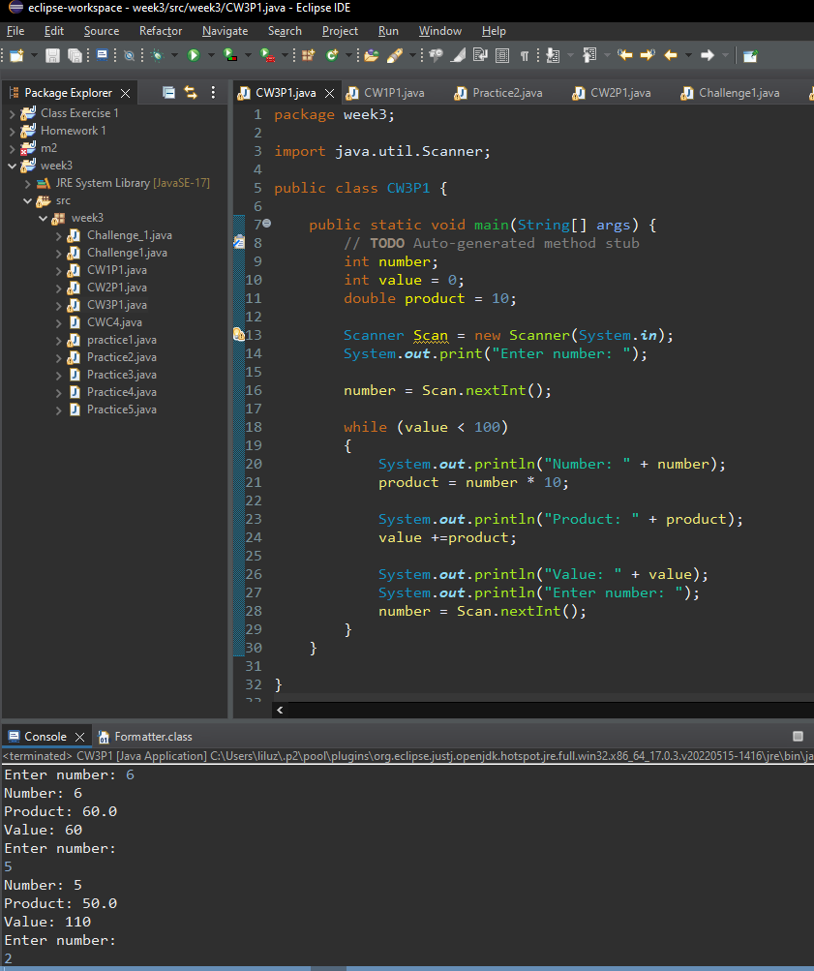

**Challenge Exercise #4:** Complete the following program below.



**#4 print screen the output with code below here.**

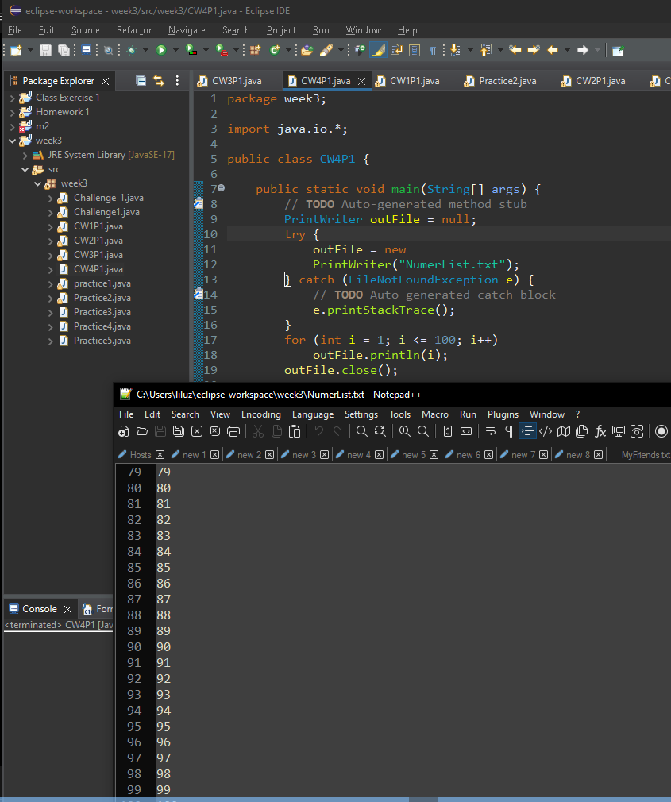

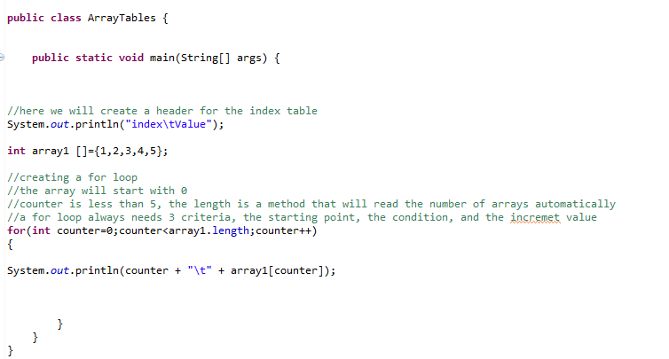

Here is an example of totaling arrays using a For Loop

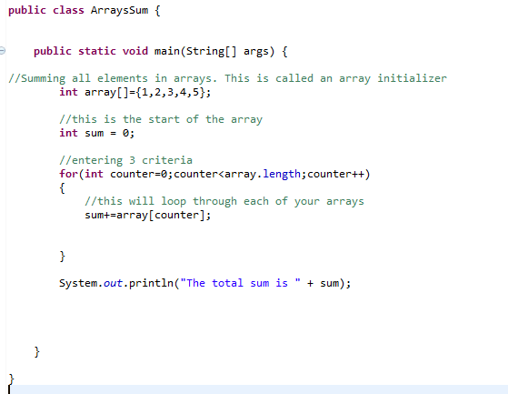

Using a Random Generator and a File Writer Class

Create a new class and name it RandomApp

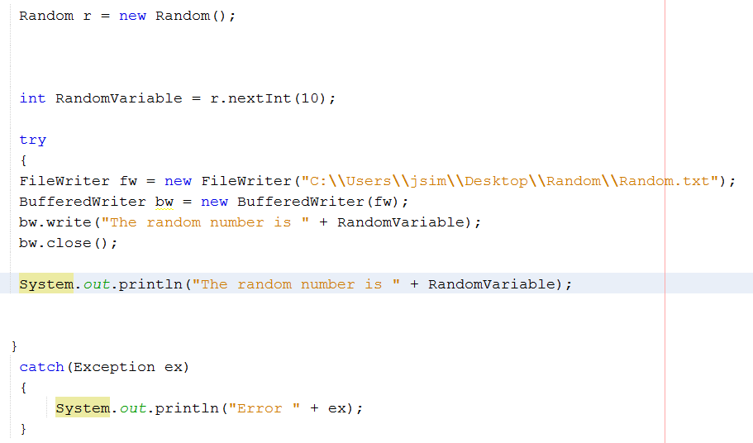

The Random Generator

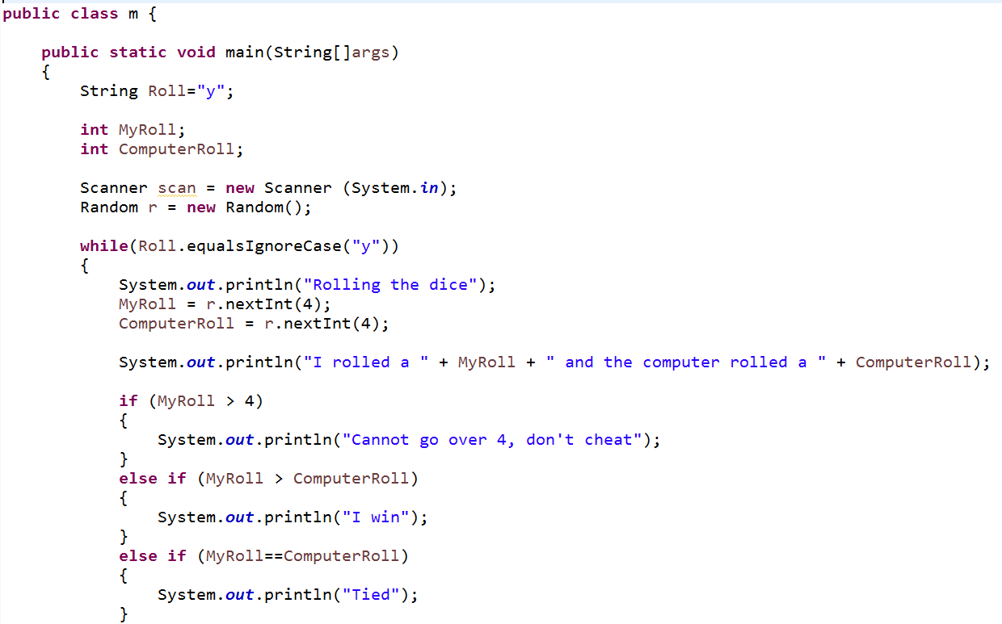 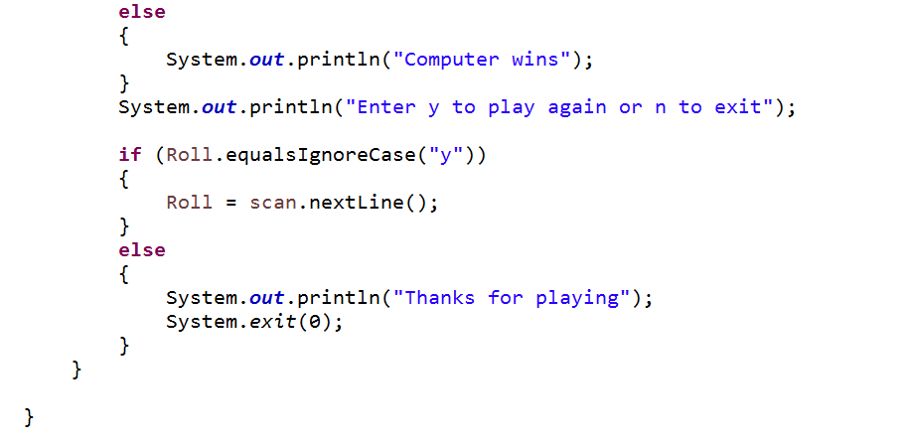

**Submit this document to Module 3 Class Exercise.**